Technical Rider & Stage Plan
First of all, thank you for your interest in booking a show for Moses Mo and the RCB. Below is a list of our technical requirements. It might sound a bit formal to you, this is not meant to cause any inconveniences on your behalf. We designed this rider for optimum effectiveness at the day of the show. If there are any questions or if you have trouble providing any of the below mentioned please get in touch with us before the day of the show and we will work out a solution.
Our Stage Setup is:
- 1 Drumset
- 1 Bass Guitar
- 1 Electric Guitars
- 1 Keyboard
- 5 Vocals
We assume that there is a well sized PA system provided for the concert room with sufficient power to supply a clean and undistorted 110dB SPL RMS to the mixing desk and a powerful and feedback-proof monitor system. It is very important that the singers and the drummer each have their own monitor speakers with separate mixes. For venues over 300 people we will need two extra monitors for the guitar and bass players and two sidefills for 500+ venues.

Contact Moses Mo and the RCB, Terra Moore: (770) 330-3423

The Minimal Set Up
for small venues, up to 150 people (microphones are listed in order of preference)

DRUMS
KICK | Shure Beta 52, AKG D12E, Shure Beta 91A, Electrovoice PL20 / RE20, Beyer M88, AKG D112, Sennheiser MD421
SNARE(S) | Sennheiser e604, Shure SM57
HI HAT | Shure SM57, Shure SM81, Neumann or Gefell small diaphragm condenser, AKG C451, any small diaphragm condenser
OVERHEAD | Shure SM81, AT 2020, Neumann or Gefell small diaphragm condenser, AKG C451, any small diaphragm condenser (left & right)
BASS | Amplifier has a DI output or choose an external DI interface
ELECTRIC GUITAR  KEYBOARDS | Sennheiser e906, Sennheiser MD421, Shure SM57  Two DI outputs for stereo left & right in keys
DRUM VOCAL | Shure Beta 58, Shure SM58
BASS VOCAL | Shure Beta 58, Shure SM58
EV VOCAL | Shure Beta 58, Shure SM58
MOSES VOCAL | Shure Beta 58, Shure SM58
ZEROBASEMENT VOCAL | Shure QLX Wireless Handheld, Shure ULX Wireless Handheld, Shure BLX Wireless Handheld, Shure SM58

MixingConsole (In order of preference)
Midas M32 or Behringer X32 (no compact or producer), A&H GLD 112, A&H GLD 80 – NO PRESONUS. See page Six for additional details.

The Complete Set Up
for venues larger than 150 people (microphones are listed in order of preference)

DRUMS
KICK | Shure Beta 52, AKG D12E, Shure Beta 91A, Electrovoice PL20 / RE20, Beyer M88, AKG D112, Sennheiser MD421
SNARE(S) | Sennheiser e604, Shure SM57
HI HAT | Shure SM57, Shure SM81 Neumann or Gefell small diaphragm condenser, AKG C451, any small diaphragm condenser
RACK TOM | Sennheiser e604, Sennheiser MD421, Beyer M88, any suitable dynamic mic
FLOOR TOM | Sennheiser e604, Sennheiser MD421, Beyer M88, any suitable dynamic mic
OVERHEAD | Shure SM81, AT 2020, Neumann or Gefell small diaphragm condenser, AKG C451, any small diaphragm condenser (left & right)
BASS | Amplifier has a DI output or choose an external DI interface
ELECTRIC GUITAR  KEYBOARDS | Sennheiser e906, Sennheiser MD421, Shure SM57  Two DI outputs for stereo left & right in keys
DRUM VOCAL | Shure Beta 58, Shure SM58
BASS VOCAL | Shure Beta 58, Shure SM58
EV VOCAL | Shure Beta 58, Shure SM58
MOSES VOCAL | Shure Beta 58, Shure SM58
ZEROBASEMENT VOCAL | Shure QLX Wireless Handheld, Shure ULX Wireless Handheld, Shure BLX Wireless Handheld, Shure SM58

MixingConsole (In order of preference)
Midas M32, Behringer X32 (no compact or producer), A&H GLD 112, A&H GLD 80 – NO PRESONUS. See page Six for additional details.

ZeroBasement Vox - Rapper
Mike Vox - Bassist
Moses Vox - ELG

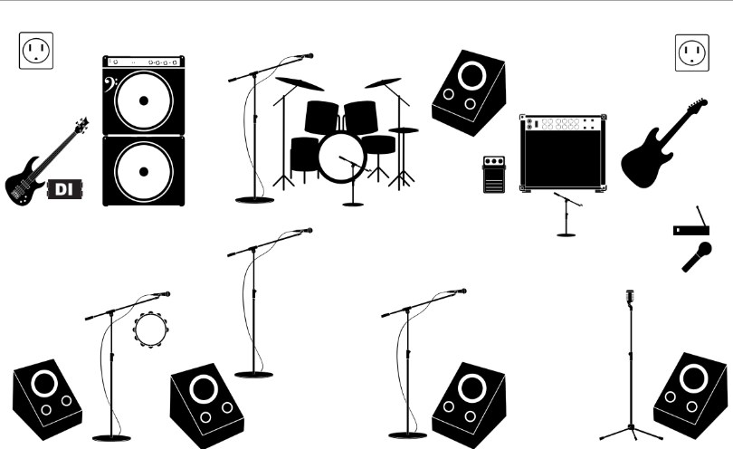
Stage Plan
)
Up Stage
(

(
Down Stage
)

EV

Vox
-

BGV

Drum

Vox
-

Drummer

Notes:

Input List (Microphones listed in order of preference) *(CHANNEL NAME)
- CH 1: Kick (K)
- CH 2: Snare 1 (SN1)
- CH 3: Snare 2 (SN2)
- CH 4: Hi Hat (HH)
- CH 5: Rack Tom (T1)
- CH 6: Floor Tom (T2)
- CH 7: Overhead L (OH L)
- CH 8: Overhead R (OH R)
- CH 9: Bass DI (Bass)
- CH 10: Electric Guitar (EL 1)
- CH 11: spare
- CH 12: Mike Vox (Bass)
- CH 13: Drum Vox
- CH 14: Poizen EV Vox
- CH 15: Zerobasement Vox
- CH 16: Moses Vox ELG)

Monitors
- Buss 1: Drum Monitor (Drum)
- Buss 2: Bass Monitor (Mike)
- Buss 3: Electric Guitar Monitor (Moses)
- Buss 4: ZeroBasement Monitor (Zero)
- Buss 5: Poizen EV Monitor (Poizen)
NOTES:

Additional Equipment
- 4 Boom mic stand and 1 Straight mic stand for vocalist
- Wireless Mic (Frequency must be in the legal range)
- Floor carpet (approx. 8 feet x 8 feet) for drums on the stage

Staff
We will need a qualified stage technician and lights technician.
Mixing Console (In order of preference)
Midas M32, Behringer X32 (no compact or producer), A&H GLD 112, A&H GLD 80 – NO PRESONUS
Analog Mixing Console - If approved by our Sound Engineer; we will need 12 compressors and 6 gates, 2 Chorus Effects and 2 Delay Effects processors.

Lighting
Lighting can be discussed during soundcheck, it is important though that during the show there is always sufficient light for the Vocals (spotlight on each musician). Use fog and strobe effects is allowed with taste.

Equipment Sharing & SoundCheck
The drummer always plays his own drumset and will not share his drums with the other bands unless otherwise discussed prior to show day. Apart from that we might share our guitar cabinet (4x12“) and the bass cabinet (8x10“), but this needs to be discussed well before the show.
We will need an absolute minimum of 45 minutes soundcheck, 60 to 90 minutes including setup would be perfect.

Arrival
Please provide detailed directions in english language two weeks before the date of the show with the complete address of the venue and a telephone contact. We need a safe parking space available for the van close to the venue. Please provide arrival, soundcheck and doors-open and on-stage times. The promoter or another person should be at the venue at arrival time.

Food and Drinks
- 10 meals or 8x $12 for buy-out
- minimum 24 bottles of cooled non-carbonated water for stage and backstage
- minimum 24 bottles of beer for stage and backstage (Beer brand to be confirmed by Tour Manager prior to arrival).
- If applicable, Breakfast for 10 persons the morning after the show.

Backstage
A separate room for the band to get some rest before and after the show. It must to have some sofas, tables, chairs, a mirror and sink.

Sleep (Overnight Accommodations) (IF APPLICABLE)
5 Double Occupancy hotel rooms, with a minimum of 2 queen beds (4 Star rating a must). A safe parking space near the sleeping accommodation should be available.

Merchandise
A table (6 feet length) and a small light for our merchandising in the same room as the show, if possible. Miscellaneous
A guest list of 25 persons.

Advertising & Promotion
There’s a large amount of promo material we can send to you for advertising purposes. Don`t hesitate to write, if you need posters or flyer and promo templates, logos or pictures in various file formats. Just get in contact with us. There`s no corporate identity in our advertising, but a corporate feeling for what the band is.

